Learning that Connects

Appointment of
Personal Coach

Required for September 2020
Full time, All Year, Permanent
Grade N5: £ 22,021 to £23,836 pa
(pay award pending)

Closing Date: 6 May 2020

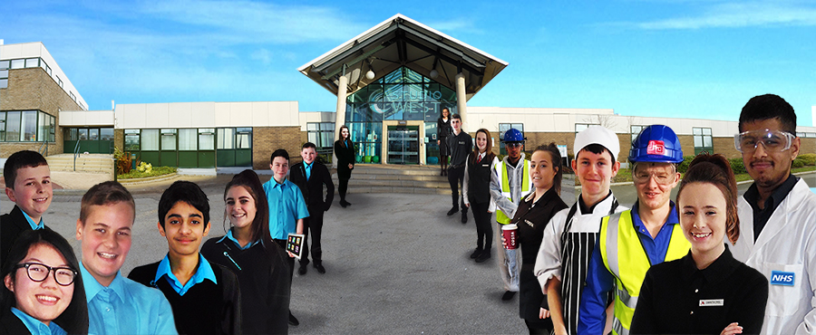

Studio West, West Denton Way, Newcastle upon Tyne, NE5 2SZ, Telephone: 0191 481 3710
Email: admin@studiowest.newcastle.sch.uk

Introduction from the Principal
Dear Applicant

Thank you for your interest in the role of Personal Coach at Studio West. Further details including a detailed job description and person specification are enclosed for your information.
Studio West is an exciting studio school, which opened in September 2014. As part of Kenton School’s Academy Trust, Studio West cater for around 400 students aged between 11 and 19 with student numbers increasing year on year. We are expected to reach 650 at full capacity. Rated “Good” by Ofsted, Studio West offers students a robust academic suite of qualifications ranging from A Level to GCSE; we also offer specialist occupational and professional qualifications.
All students benefit from an innovative and bespoke curriculum with substantial emphasis on developing key employability and life skills that will see them through to HE, FE and employment. Much of our curriculum is delivered through Project Based Learning where ‘learning connects’ in a very real sense. We have close working relationships with our business partners and our mission is to make sure that every student who leaves Studio West, does so with a university place, an apprenticeship or employment.

The Personal Coach is a challenging and varied role that places pastoral care at the heart of students’ learning. Our team of Personal Coaches work with individual and groups of students to develop individual learning plans and ensure that every student’s curriculum and work-related learning needs, are met. Personal coaches act as a key link point between all aspects of the curriculum and Learning Coaches, this ensures that the curriculum is holistic, personalised and fully compliant will all relevant National Curriculum requirements. They play a central part in shaping core projects to meet every student’s needs and goals, working with students and Learning Coaches to adapt the project and ensure that students have the support they require to succeed. Personal coaches support students through the work placements, providing them with personalised support, training and tracking on a frequent and regular basis. They also actively guide and advise students on the progression routes available to them.

We are seeking applications from candidates with significant experience of working with children and young people in a learning environment, with the ability to manage and motivate students to ensure positive learning outcomes. Candidates must possess an understanding of the barriers to learning for children and young people and a working knowledge of strategies to overcome them. This, combined with excellent interpersonal skills and the ability to form effective, professional relationships with all stakeholders is an integral part of the post. And, most importantly, candidates must have the ability and flexibility to adapt to ensure that the needs of all students are met.

If you feel you have the experience, skills and attributes to succeed as part of our team, please complete the online form via www.tes.com/jobs/ selecting ‘Quick Apply’ or download an application form from our website www.studiowestnewcastle.com and return it to human.resources@kenton.newcastle.sch.uk no later than 12.00 Noon on 6 May 2020. We look forward to receiving your application.

Yours sincerely
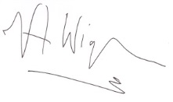
Val Wigham, Principal

Personal Coach

Job Description

Payscale: | N5
Responsible to: | Principal
Job Purpose: | To act as a key link point between all aspects of the curriculum, working with students and learning coaches to ensure that the curriculum is holistic, personalised and fully compliant with National Curriculum requirements.

Main responsibilities:
The following list is typical of the level of duties which the post holder will be expected to perform. It is not necessarily exhaustive and other duties of a similar type and level may be required from time to time.

- To negotiate core project delivery by working with students at the beginning of projects to tailor them to meet their goals and training requirements.

- To plan and co-ordinate personalised learning plans and routes for allocated students.

- To support students to reflect on and evaluate their progress, setting personalised targets.

- To liaise with staff within the studio school and local businesses to monitor and observe students’ progress and to put strategies in place to address any underperformance.

- To work with learning coaches to provide support for core projects and single lesson sessions, helping to ensure that all National Curriculum requirements are delivered.

- To make students aware of progression routes available to them and how their learning relates to them.

- To act as the primary link with parents, building relationships with parents to ensure that they are aware of the progress that their children are making.

- To work with other personal coaches on a whole school strategy for effective pastoral care.

- To work with students and staff to create links with local community leaders, businesses and organisations.

- To participate in the professional and collegiate work of the school.

- To contribute to the formation and implementation of school and departmental improvement plans.

- To comply and assist with the development of policies and procedures relating to child protection/ safeguarding, health, safety and security, confidentiality and data protection, reporting concerns to an appropriate person.

- To promote and implement the school’s equal opportunities policies in all aspects of employment and service delivery.

Person Specification | Essential or  Desirable | Assessed  A: Application  I: Interview
Education/Qualifications
Effective literacy and numeracy skills (level 2 qualification or above including mathematics and English. | E | A
Experience
Previous experience working with secondary school age students in a paid or voluntary capacity. | E | A
Previous experience working with secondary school age students in a learning environment. | D | A
Experience of advancing students learning through mentoring or tutoring, including working with individuals and small groups. | D | A/I
Experience designing coaching sessions. | D | A/I
Experience using a range of behaviour management strategies. | D | A/I
Evidence of improved student outcomes. |  | A/I
Skills/Knowledge
Understanding of the principles of child development and learning processes. | E | A/I
Understanding of the barriers to learning and strategies to put into place to overcome those barriers. | E | A/I
Understanding of the use of assessment to inform planning. | D | A/I
Good knowledge of effective and engaging teaching methods and current planning and assessment procedures. | D | A/I
Ability to plan lessons and sessions with clear objectives and to ensure progression for all students. | E | A/I
Able to create a motivating learning environment and programmes of work which take account of individual students’ needs. | E | I
Ability to set consistently high expectations for all students through class work and homework. | E | I
Personal Attributes
Excellent interpersonal and oral and written communication skills. | E | A/I
Able to work flexibly as part of a team and using own initiative. | E | I
Ability to persuade, negotiate, influence and gain co-operation. | E | I
Commitment to the principles and ethos of Studio West. | E | I
Maintains high professional standards at all times. | E | I
Committed to own professional development. | E | I
Additional Requirements
Satisfactory Disclosure and Barring Service check at Enhanced Level and Children’s Barred Persons List Check | E
Satisfactory medical clearance | E
Proof of qualifications | E
A minimum of two satisfactory references from current and previous employers (or education establishment if not in employment) | E

Additional Information for Applicants

Terms and Conditions
The conditions of service applicable to the post are those determined by the National Joint Council for Local Government Services (the National Agreement) and locally agreed terms and conditions.

Working Hours
The working hours for this post are 37 hours per week. Normal working hours are Monday to Thursday 8 am to 4 pm and Fridays 8 am to 3.30 pm with a 30 minute unpaid lunch break each day.

Annual Leave Entitlement
The annual leave entitlement for the post is 23 days plus 8 public holidays rising to 28 days plus 8 public holidays on completion of 5 years’ or more continuous Trust or local government service.

Pay and Grading
The grade of the post is N5, equivalent to local government pay spine points 21 – 25, with current corresponding full time salary of £22,021 to £23,836 pa.

Progression through the grade is by annual increments on the 1 April each year until the top of the grade is reached. Where 1 April falls within the six month probationary period, the increment is held and is paid on the 1st of the month following successful completion of the probationary period and from 1 April thereafter.

Please note there is a pay award pending effective from 1 April 2020.

Probationary Period
New entrants to Kenton Schools Academy Trust are subject to a six month probationary period.

Safeguarding
Kenton Schools Academy Trust is committed to safeguarding and promoting the welfare of children and young people in all our schools and expects all staff and volunteers to share this commitment. We are fully committed to ensuring that consistent effective safeguarding procedures are in place to support families, children and staff at school.

Equal Opportunities
The school is opposed to any form of unfair discrimination and is publicly committed to be an equal opportunity employer.

Pension Scheme
On appointment, new associate staff will be automatically joined into the Local Government Pension Scheme (unless they choose to opt out). Further information can be found at www.twpf.info.

Application Process
You can apply either by completing the online form via www.tes.com/jobs/ selecting ‘Quick Apply’ or download an application form from our website www.studiowestnewcastle.com and return it to human.resources@kenton.newcastle.sch.uk. Please note as school is closed, we are not able to accept applications by post at this time, but please contact us if you have any issues regarding the application process.

Closing date: 12.00 Noon on 6 May 2020

