Learning that Connects

Appointment of
Kitchen Assistants

18.5 hours per week, term time plus 5 training days
Grade N2, Actual salary: £9.18 per hour
Annual Salary: £7,537 pa
Required for September 2020

Closing Date: 10 July 2020

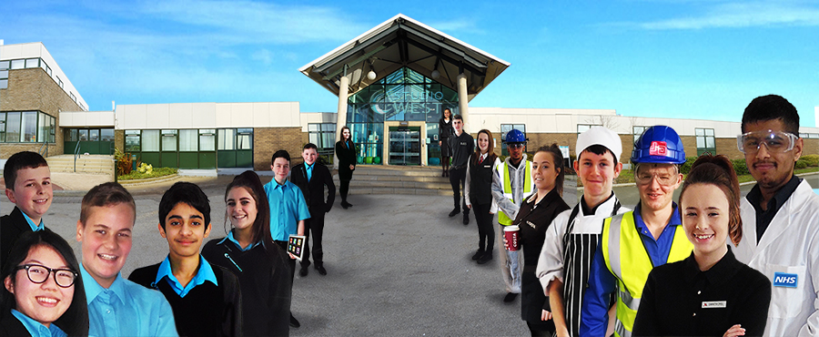

Studio West, West Denton Way, Newcastle upon Tyne, NE5 2SZ, Telephone: 0191 481 3710
Email: admin@studiowest.newcastle.sch.uk

Introduction from the Principal

Dear Applicant

Thank you for your interest in the role of Kitchen Assistant Studio West.
Studio West is an exciting studio school, which opened in September 2014. As part of Kenton School’s Academy Trust, Studio West cater for around 400 students aged between 11 and 19 with student numbers increasing year on year. We are expected to reach 650 at full capacity. Rated “Good” by Ofsted, Studio West offers students an innovative and bespoke curriculum with an emphasis on employability and life skills. We have close working relationships with our business partners and our mission is to make sure that every student who leaves Studio West, does so with a university place, an apprenticeship or employment.
Due to our expansion, we are delighted to be introducing two new Kitchen Assistant posts to our team. The roles will involve supporting the Catering Manager in the preparation, cooking and serving on high quality, nutritious food.

The role will also involve ensuring that the kitchen area is kept clean, adhering to strict food hygiene, health and safety and Covid-19 related procedures.

If you are the person we are looking for, you will have previous experience in a catering/cooking background, combined with excellent customer service skills. A current Food Hygiene Certificate would be desirable but we can ensure appropriate training for those without this.

The hours are 18.5 per week, working 3 per day Monday to Friday around the lunch period, with an additional 3.5 hours to be worked on one of the days.

If you feel you have the experience, skills and attributes to succeed as part of our team, please download an application form from our website www.studiowestnewcastle.com or email us at human.resources@kenton.newcastle.sch.uk no later than 12.00 Noon on 10 July 2020. You can also request an application form by phone on 0191 481 3710 or 0191 214 2206. Please leave a message and we will call you back.

We look forward to receiving your application.

Yours sincerely
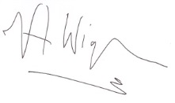
Val Wigham
Principal

Job Description

Payscale: | N2
Responsible to: | Catering Manager
Job Purpose: To assist with the efficient and effective delivery of a quality, efficient and friendly school meals service through the preparation and service of meals in accordance with agreed standards and procedures.

MAIN DUTIES:
The following is typical of the duties the postholder will be expected to perform. It is not necessarily exhaustive and other duties of a similar nature and level may be required from time to time.

- To carry out all aspects of kitchen related duties to ensure the preparation and service of a quality meal and the maintenance of all hygiene standards.

- To undertake the preparation and cooking of food and beverages in accordance with agreed procedures and using all equipment necessary.

- To ensure the presentation and service of food to the customer is in accordance with agreed procedures, providing a brief description, if requested, of the meals available and to encourage customers to purchase more or try other foods (i.e. balanced diet).

- To assist with the general maintenance and presentation of the service area.

- To wash utensils, crockery, pots and pans, and undertake general cleaning of the kitchen area including equipment and machinery, storerooms and staff rooms, to the required hygiene standards.

- To clean the dining room and set up and clear away equipment and materials if necessary.

- The participation in and assistance with functions where catering is required.

- The postholder will have a responsibility for promoting and safeguarding the welfare of children and young people s/he is responsible for, or comes into contact with, in accordance with the trust’s safeguarding policy and school’s child protection policies and protocols.

- To promote and implement the Council’s equal opportunities policies in all aspects of employment and service delivery.

- To assist in maintaining a healthy, safe and secure environment and to act in accordance with the Council's policies and procedures.

Person Specification

Criteria | Essential or  Desirable | Assessed  A: Application  I: Interview
Education/Qualifications
NVQ Level 2 in Food Preparation and Cooking or equivalent. | D | A
Food Hygiene Certificate (Candidates who do not have this will be required to complete and obtain the qualification on appointment) | D | A
Experience
Experience working in a busy kitchen producing high quality meals. | D | A/I
Skills/Knowledge
Sound knowledge of health and safety in a kitchen environment. | E | A/I
Understanding of principles of safe storage of food. | E | A/I
Knowledge of a wide range of cooking techniques with evidence of continuing skills development. | D | A/I
Personal Attributes
Excellent interpersonal and oral communication skills. | E | A/I
Able to work flexibly as part of a team and using own initiative. | E | I
Commitment to the principles and ethos of Studio West. | E | I
Maintains high professional and personal standards at all times. | E | I
Committed to own professional development. | E | I
Additional Requirements
Satisfactory Disclosure and Barring Service check at Enhanced Level including Children’s Barred List Check | E
Satisfactory medical clearance | E
Proof of qualifications as outlined on application form | E
A minimum of two satisfactory references from current and previous employers (or education establishment if not in employment) | E

Additional Information for Applicants

Terms and Conditions
The conditions of service applicable to the post are those determined by the National Joint Council for Local Government Services (the National Agreement) and locally agreed terms and conditions.

Working Hours
The working hours for this post are 18.5 hours per week. Normal working hours are 3 hours per day Monday to Friday with an additional 3.5 hours to be worked on one day a week. We are looking for flexibility in hours to ensure adequate coverage over the lunch period and will offer flexbilty in return.

Annual Leave Entitlement
As this is a term time only post, annual leave entitlement is incorporated into annual salary. This equates to an additional 5.26 weeks pay (23 days plus 8 public holidays pro rata to weeks worked) for staff with less than 5 years’ continuous local government service, and 6.25 weeks pay (28 days plus 8 public holidays pro rata) for staff with 5 years’ or more continuous local government service.

Pay and Grading
The grade of the post is N2, equivalent to local government pay spine point 2, with current corresponding full time salary of £17,711 pa. The actual salary for this post, based on 18.5 hours per week including annual leave entitlement as outlined above and 5 training days is as follows:-
Less than 5 years’ continuous local government service: £7,537 pa
5 or more years’ continuous local government service: £7,705 pa

Please note there is a pay award pending from 1 April 2020.

Probationary Period
New entrants to Kenton Schools Academy Trust are subject to a six month probationary period.

Safeguarding
Kenton Schools Academy Trust is committed to safeguarding and promoting the welfare of children and young people in all our schools and expects all staff and volunteers to share this commitment. We are fully committed to ensuring that consistent effective safeguarding procedures are in place to support families, children and staff at school.

Equal Opportunities
The school is opposed to any form of unfair discrimination and is publicly committed to be an equal opportunity employer.

Pension Scheme
On appointment, new associate staff will be automatically joined into the Local Government Pension Scheme (unless they choose to opt out). Further information can be found at www.twpf.info.

Application Process
You can apply either by downloading an application form from our website www.studiowestnewcastle.com and returning it to human.resources@kenton.newcastle.sch.uk. Alternatively please contact us on 0191 481 3710 to arrange for an application pack to be sent to you.
Closing date: 12.00 Noon on 10 July 2020

